Homework: Scatterplot Matrix and parallel coordinates

Due: 6 points

Revise the plot in 3.3

# 3.3: Revise the plot

Follow the suggestions at the end of section 2. Put units of measure in variable labels. Add a figure caption with data location, time period. Cleveland’s book as a reference and his reference

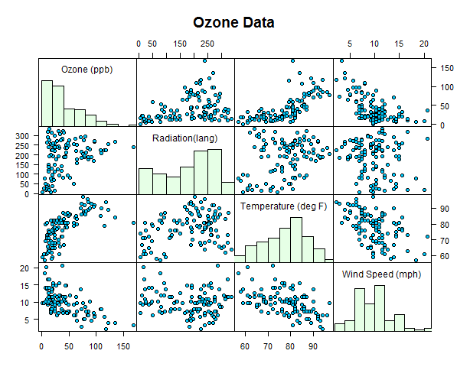

# 3.4

# 5.1 or 5.2

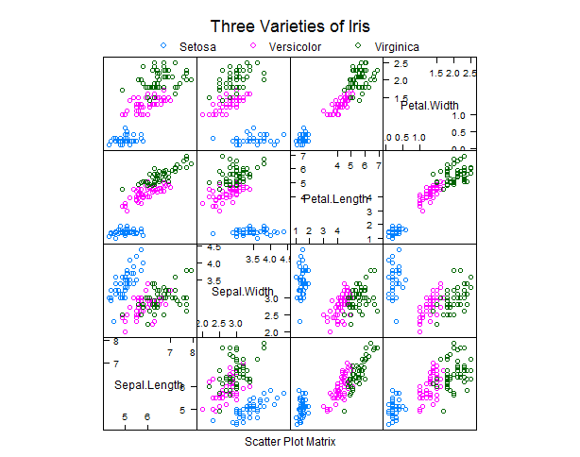

# 6

